CHANGE ACCOUNTS PAYABLE CHECK NUMBER

Util/chgapchk.r

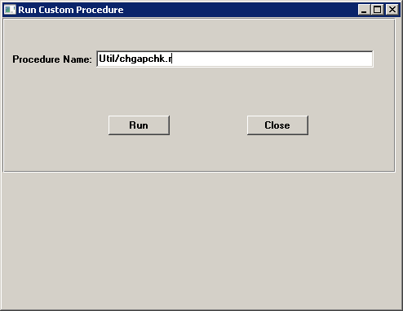

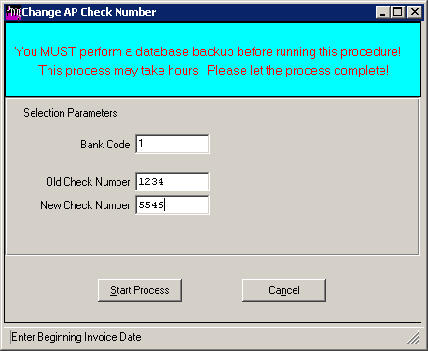

Enter the Bank code attached to AP check to change

Enter the Old check number

Enter the new check number that will replace the old check number

Start Process.